GEN II HAYABUSA
PROGRESSIVE NOS HARNESS

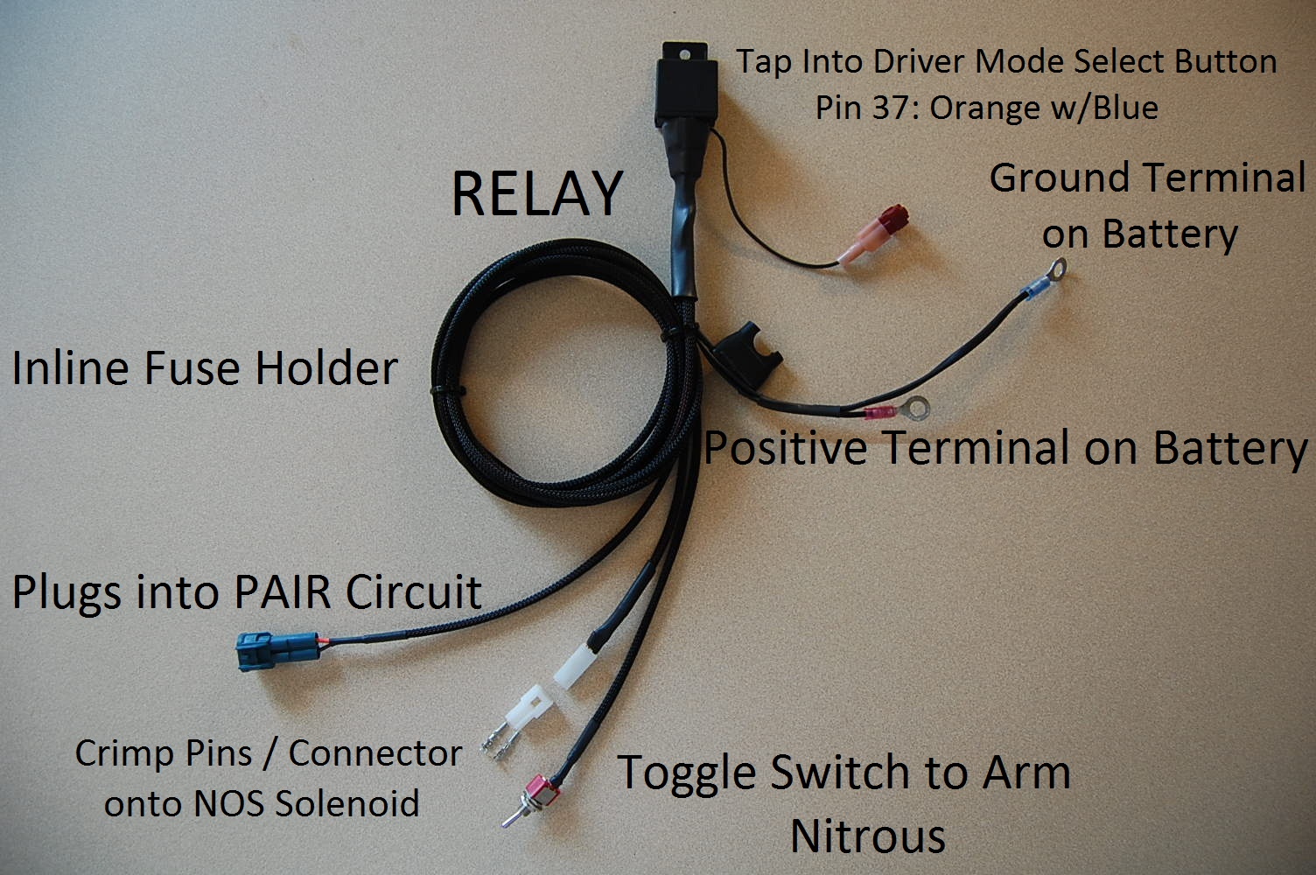

**WARNING**: For off-road use only!!!! You must have your ECU re-flashed and setup for NOS control BEFORE you install this nitrous harness. Failure to do so will damage your engine, as well as nitrous solenoid. You must install a PAIR blockoff kit prior to using the PAIR circuit to control your nitrous activation as this harness renders the PAIR system in active.

Pair Valve Connection:
Remove drivers seat and lift tank. Locate the PAIR solenoid located on top of the valve cover. Disconnect the solenoid and remove from bike and connect the plug and play 2 pin bluish green connector. Once connected you no longer have control of the PAIR system on the bike.

Toggle Switch:
The toggle switch is long enough to reach to your left side inner panels, mount where-ever is convenient. Drill a ¼” through hole for the toggle to slide up through. DO NOT OVERIGHTEN THE NUT. The toggle switch will pull itself apart if you over-torque the retaining nut.

Relay:
The relay is setup to rest between your battery and the ECU, you may need to gently lift up on the ECU’s harness to get it to fit in there snugly.

Battery Connections:
Connect the red ¼” eyelet to the positive terminal of the battery, this wire has an inline fuse holder installed, install a fuse that suited for your NOS solenoid. Connect the black wire with blue ¼” eyelet to the negative terminal of the battery. Be sure to tighten the bolts back nice and snug. A loose ground connection at your battery will cause all sorts of interesting issues.

ECU Connection:
This is optional. ECU editor is setup so that you must hold the Driver Mode UP button in order for nitrous to spray. You can either do that, or if you are like me and hate holding buttons, tap the black wire that’s coming out of the relay into pin 37 (orange with blue tracer) located on the grey connector top row (see photos). Once the toggle switch is in the armed position, this will be the same thing as holding the UP button with your thumb. Always leave the toggle switch OFF unless you really are ready to spray and in a safe environment to do so.

NOS Solenoid Connection:
Solder and or crimp on the 2 small molex pins and insert into the 2 pin white molex housing onto your nos solenoid. This will allow you to easily plug in and remove your NOS solenoid from the bike.

Under-seat connections
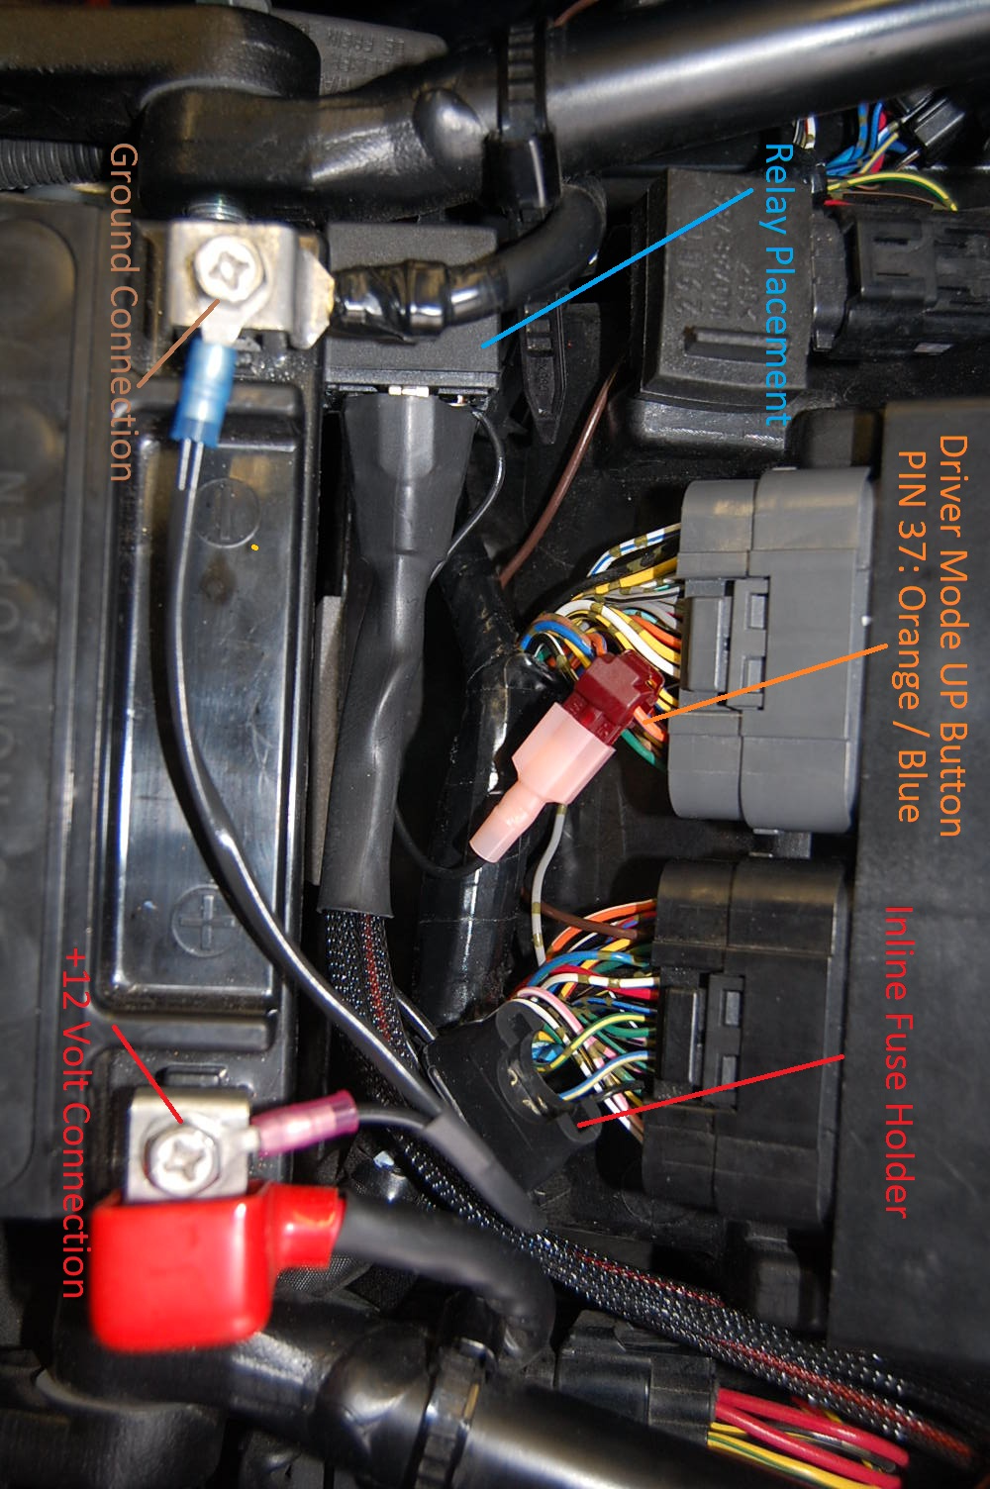

Nitrous Solenoid Connection
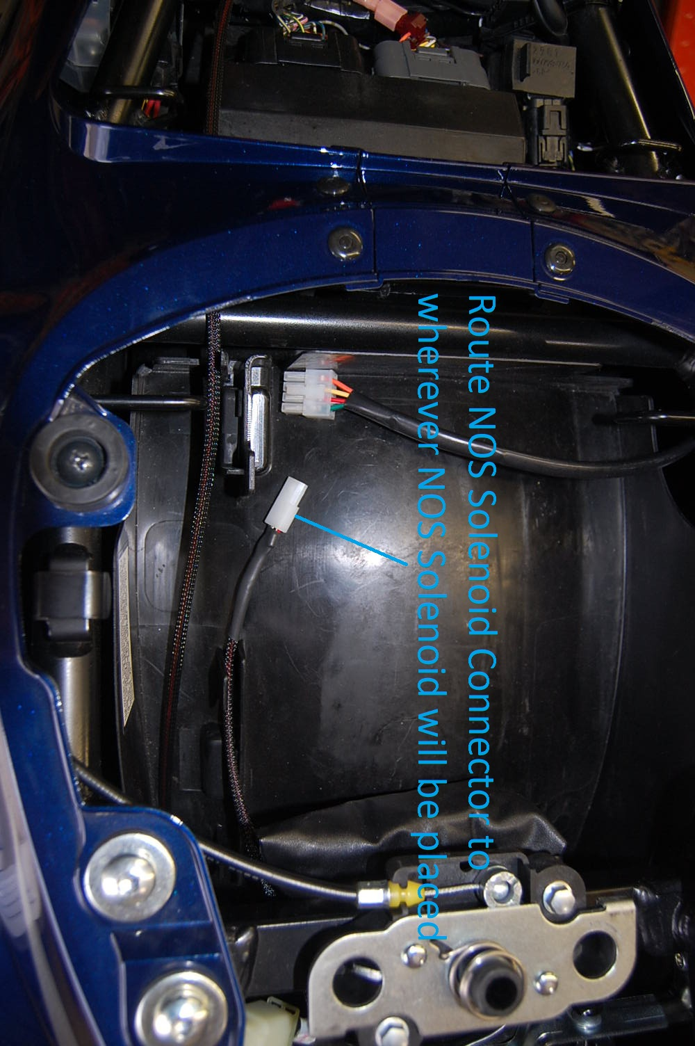
Removal of PAIR Solenoid
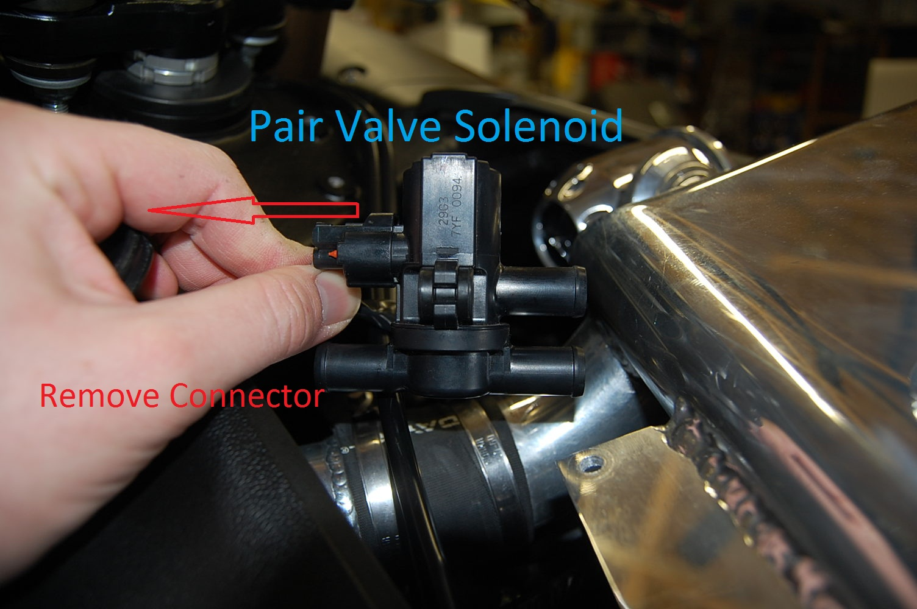

Installation of Plug and Play PAIR Connector
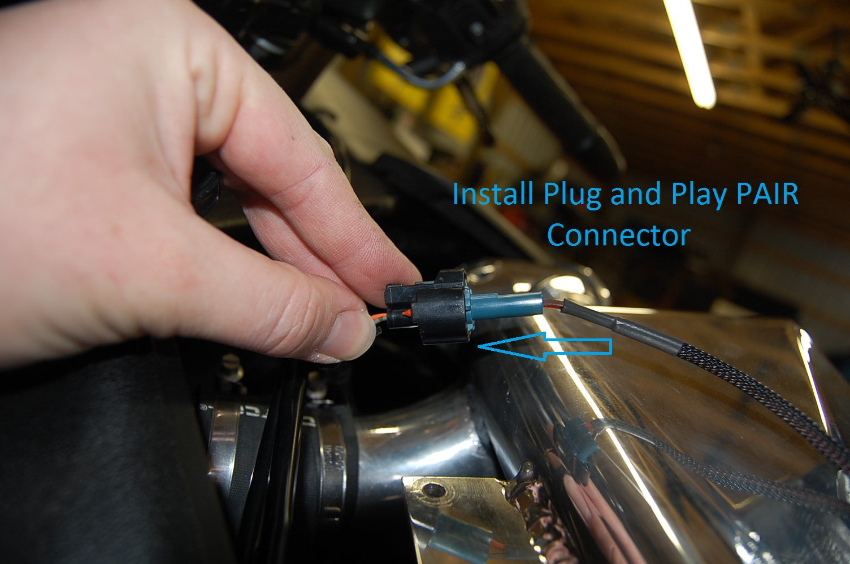

Manual Activation of NOS
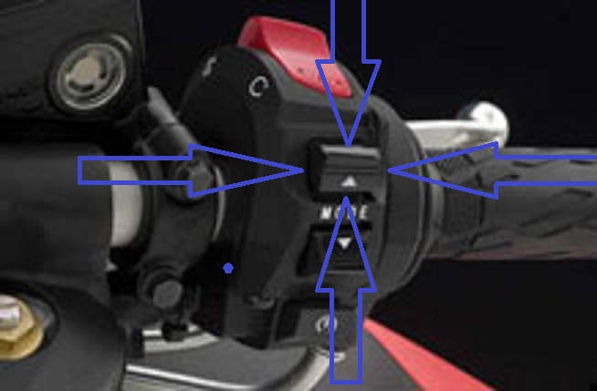

Automatic Activation using Toggle Switch
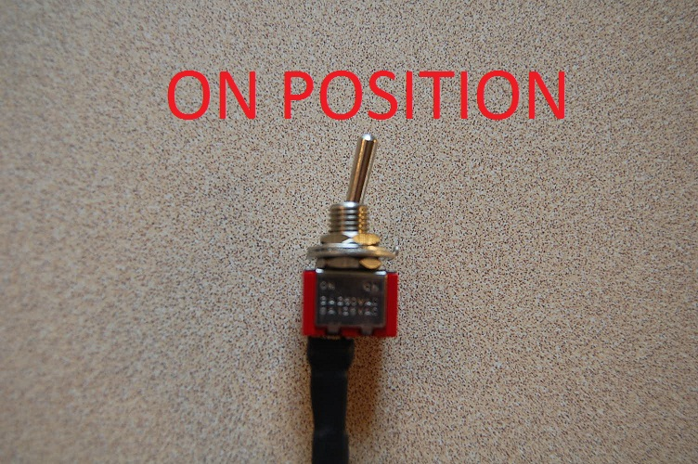
Toggle switch in OFF Position
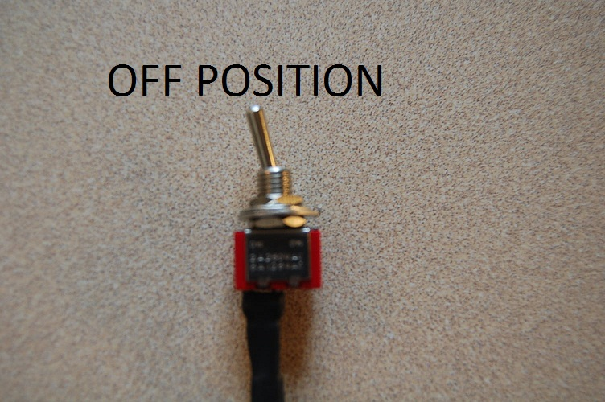

Setup in ECU Editor:
In the advanced settings tab, turn Pair Valve off, then open nitrous control button. Check the box on top of screen to activate nitrous code. Nitrous will only come on in the rpm you program for nitrous on and nitrous off rpm. TPS > 95% is hard coded in and can’t be changed. You must be wide open throttle, within the rpm window, and either pushing the mode UP button or have the toggle switch in the ON position to spray nitrous. For anything much over 240 hp is highly recommended to go to 50/50 injector balance to get enough fuel to the engine.

For each gear you can program the following using + and – on keyboard:
- Nitrous Duty Cycle: Duty cycle percent to pulse the nitrous solenoid. Not all solenoids are created equal. Pulsing a solenoid is very hard on it, and they will not last nearly as long as if they are turned on 100% like on traditional systems.
- Fuel add %: how much fuel to add on top of your base map
- Ignition retard: enter as a positive value for how much timing to pull compared to base map.
- Ramp up ms: amount of time in milliseconds (1000 ms = 1 second) it takes to reach your duty cycle setpoint / fuel add % setpoint / ignition retard setpoint. For example a ramp up 2000 ms in 2nd gear, as soon as all criteria are met to spray in 2nd gear (rpm met, TPS met, button UP or toggle in ON position), the nitrous will start at the previous gears setpoint, in the example below 1st was 0 %, so you will go from 0% duty cycle to 50% duty cycle in 2 seconds, fuel and ignition will ramp as well.
- Fuel delay is currently not active in the latest software
- Solenoid Duty Hz: for very advanced users only with previous experience tuning progressive systems etc. Novice users don’t touch this.
- Activation Type: Always leave as RPM/TPS/Button activation. (Failure to select this will cause NOS to ALWAYS SPRAY!!! READ THIS TWICE, EVERYONE MISSES IT.
- DSM Button: Upper
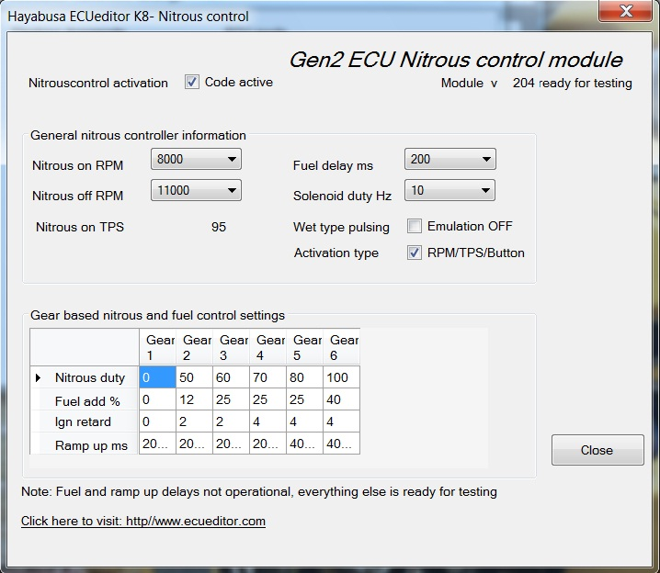

WARNINGS:
As with any nitrous controlling device, a very clear understanding of its operation is essential to keeping engine parts…….well inside the engine. Under no circumstances is it ever a good idea to add nitrous to a bike without being on a dyno to tune properly under controlled conditions. ALWAYS, ALWAYS, ALWAYS do a dry run with everything functional, except nitrous turned on (you may want to leave the solenoid disconnected to keep from burning it up) to make sure you actually get a fuel increase, and ignition retard, prior to injecting NOS into the engine. Failure to do this can and may result in severe engine damage.

Contact Information:
Greg Smith
www.boostbysmith.com
greg@boostbysmith.com
(517)743-3666 (only available in the evenings after work, 6PM EST I am home)

